AIASSISTANTASS-3.1

NAME:R. KARTHK
HTNO:2303A52202BATCH:35

Question1:
Zero-ShotPrompting(Palindrome NumberProgram)
Writeazero-shotprompt(withoutprovidinganyexamples)togenerate aPythonfunctionthat checkswhether agivennumber isapalindrome. Task:
- RecordtheAI-generatedcode.
- Testthecodewithmultipleinputs.
- Identifyany logicalerrors ormissing edge-case handling.
CODE:
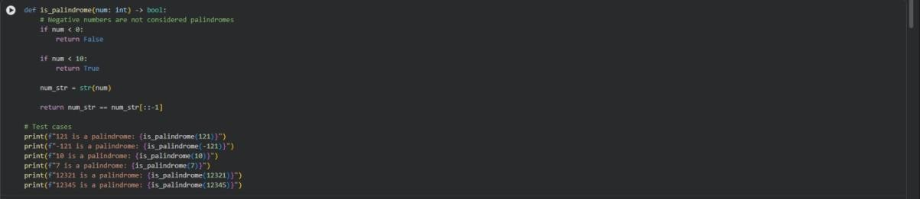
OUTPUT:
EXPLANATION:
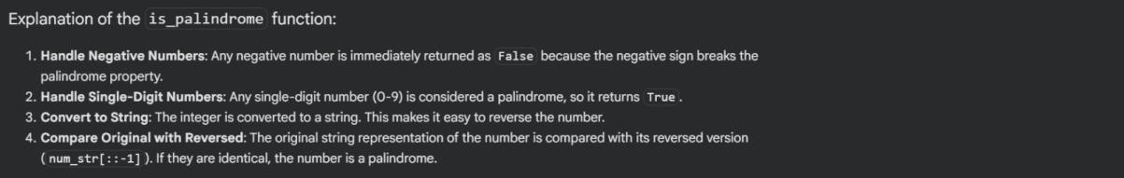

Question2:

One-ShotPrompting(FactorialCalculation)
Write a one-shot prompt by providing one input-output example and asktheAItogenerateaPythonfunctiontocomputethefactorialofa given number.
Example:
Input:5→Output:120 Task:
- Comparethegenerated codewithazero-shot solution.
- Examineimprovementsinclarityand correctness.
CODE:
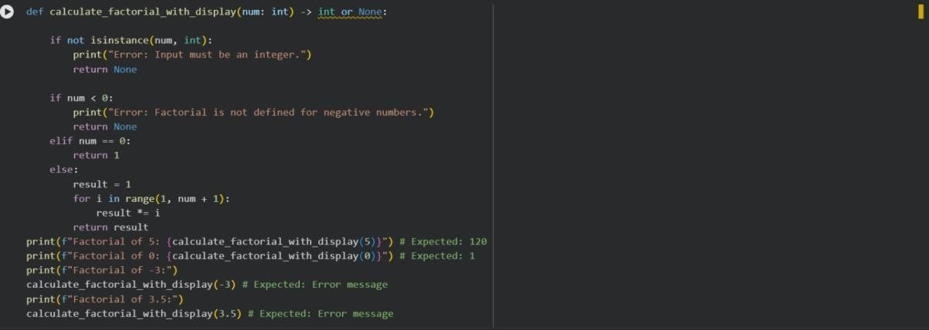
OUTPUT:
EXPLANATION:
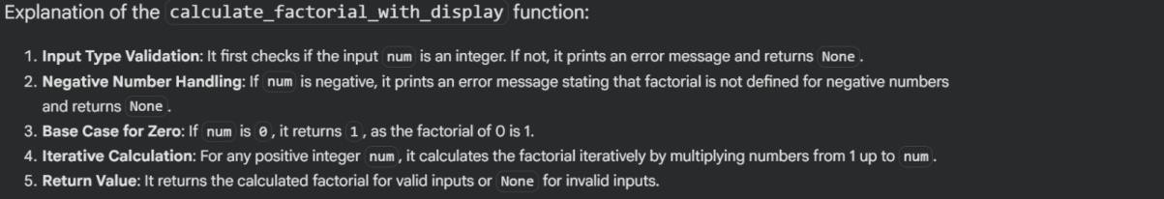

Question3:
Few-ShotPrompting(ArmstrongNumber Check)

Writeafew-shotpromptbyprovidingmultipleinput-outputexamples to guide theAI in generating a Python function to check whether a
givennumberisanArmstrongnumber. Examples:
- Input: 153→Output:ArmstrongNumber
- Input:370→Output:ArmstrongNumber •Input:123→Output: Not an Armstrong Number
Task:
- Analyzehowmultipleexamplesinfluencecodestructureand accuracy.
- Testthefunctionwithboundaryvaluesandinvalidinputs.
CODE:
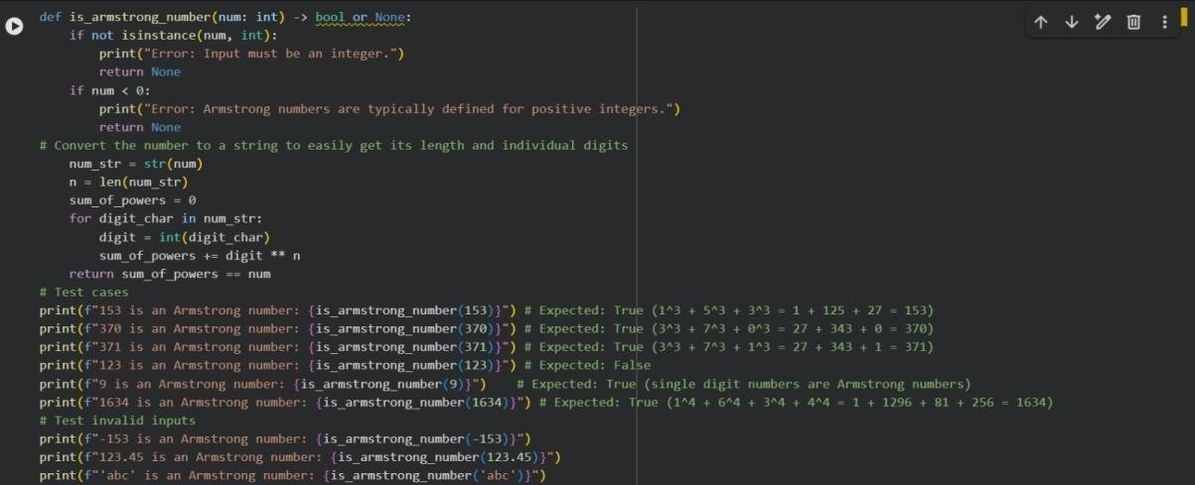
OUTPUT:
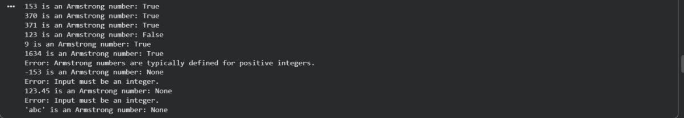
EXPLANATION:

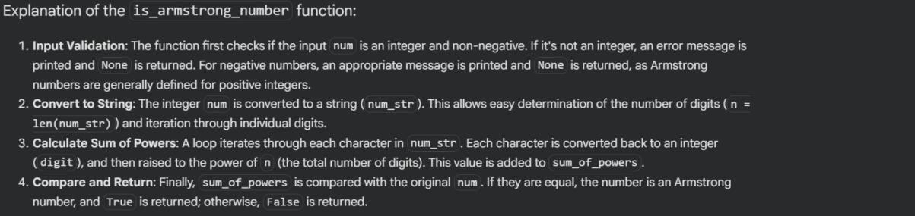

Question4:
Context-ManagedPrompting(OptimizedNumber Classification)
Design a context-managed prompt with clear instructions and constraintstogenerateanoptimizedPythonprogramthatclassifiesa number as prime, composite, or neither.
Task:
- Ensure properinputvalidation.
- Optimizethelogicforefficiency.
- Comparetheoutputwithearlier promptingstrategies.
CODE:
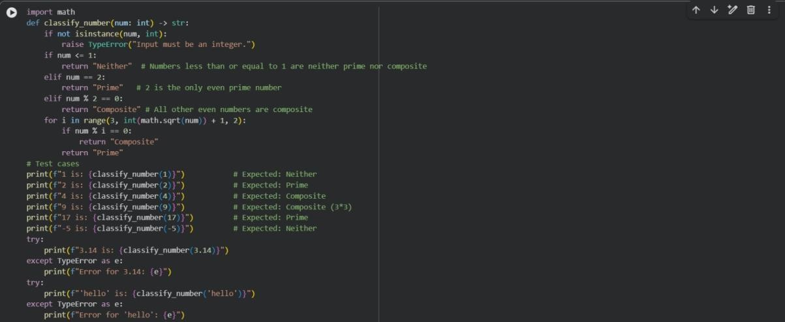
OUTPUT:
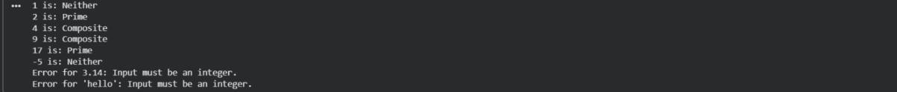
EXPLANATION:

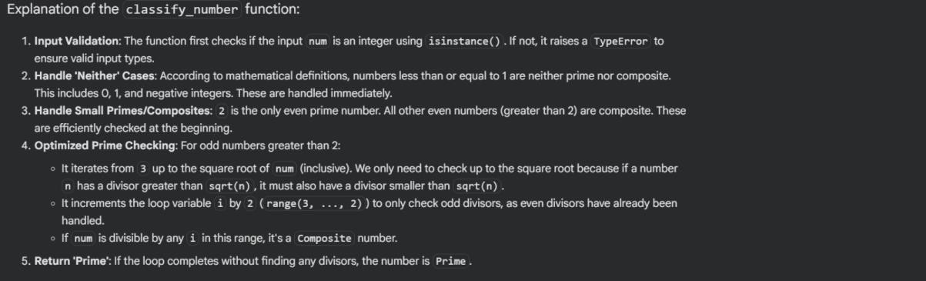

Question5:
Zero-ShotPrompting(Perfect Number Check)
Writeazero-shotprompt(withoutprovidinganyexamples)togenerate a Python function that checks whether a given number is a perfect
number. Task:
- RecordtheAI-generatedcode.
- Testtheprogramwithmultipleinputs.
- Identifyanymissingconditionsorinefficienciesinthelogic.
CODE:
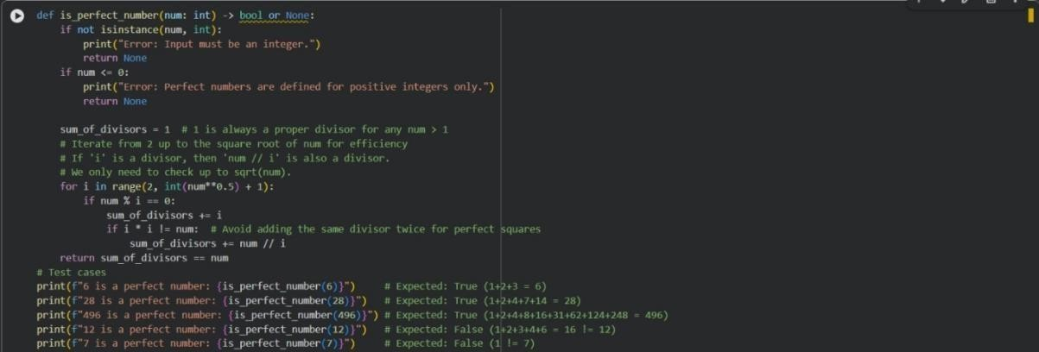
OUTPUT:
EXPLANATION:

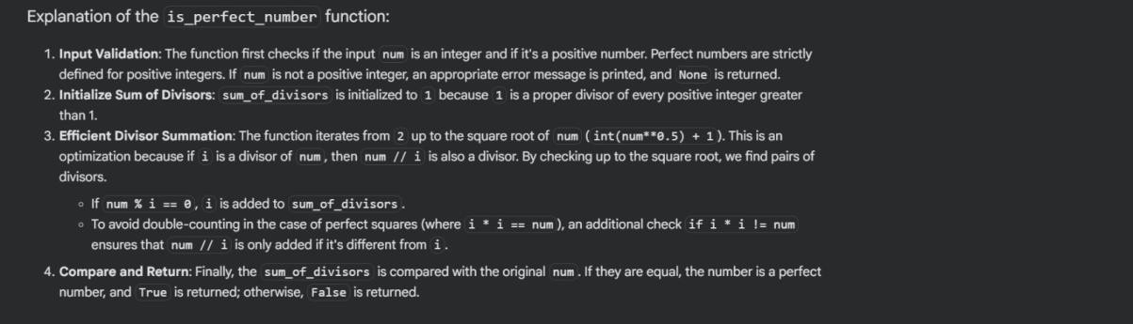

Question6:
Few-ShotPrompting(EvenorOddClassificationwith Validation)
Writeafew-shotpromptbyprovidingmultipleinput-outputexamples to guide theAI in generating a Python program that determines
whetheragivennumberisevenorodd,includingproperinput validation.
Examples:
- Input:8 →Output:Even
- Input:15 →Output:Odd
- Input:0→Output:Even Task:
- Analyzehowexamplesimproveinputhandlingandoutput clarity.
- Testtheprogramwithnegativenumbersandnon-integer inputs.
CODE:

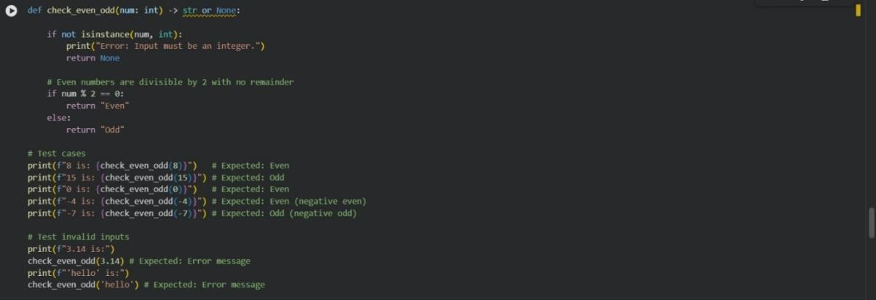
OUTPUT:
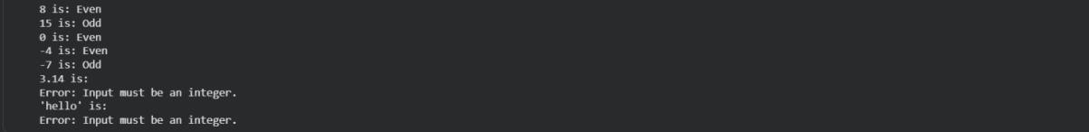
EXPLANATION:
